Computer Programming Using Python 3.3 - Console 10 - Exceptions
GOAL: Write a program that can crash due to an unforeseen situation; handle the problem using exceptions.

- Open IDLE, File, New Window, File, Save As, console10exceptions.py
- Type the following FAULTY code:
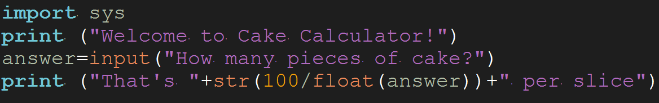

So, what is wrong with this code?

Try Run, Run Module, then tell it how many slices (4 to 8).

Run, Run Module again. Now try typing 0

To fix the horrible crash that occurs when you follow the instructions above, you can use exceptions. Change the code to the following:

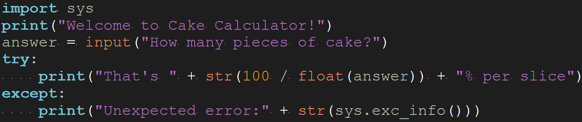

Run, Run Module again. Now try typing 0

If it worked, it should say that there was an Unexpected error, instead of crashing.

But, your customer who bought your cake calculator software is upset—they say that you may not have programmed it right because something unexpected happened. Make your program expect a division by zero to be a problem, by handling the ZeroDivisionError exception separately:

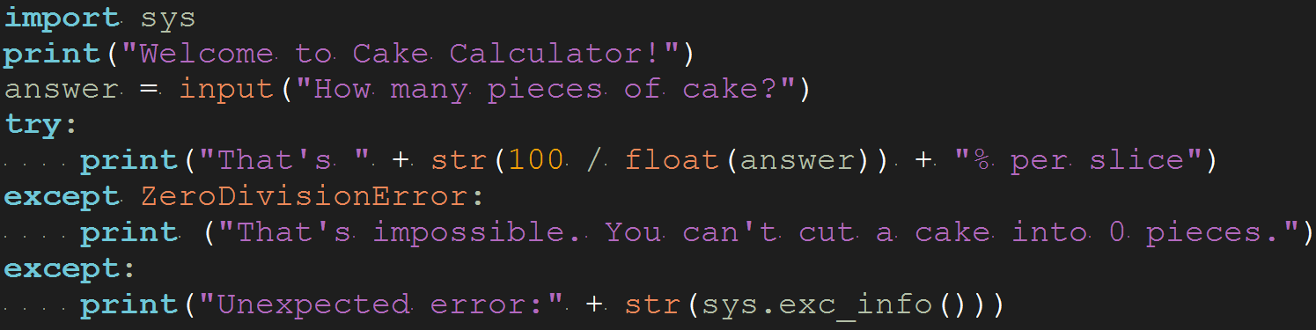

Run, Run Module again. Now try typing 0

If it worked, it should give the user the “Sorry” message above, instead of Unexpected error.

